

JK LAKSHMIPAT UNIVERSITY

DIGITAL CIRCUIT AND SYSTEMS  
(EE1120)

Activity 12

Design a full adder in FPGA boards

using VHDL language.

Date : 2nd April 2024

Name : Bobby Sharma

Roll no. = 2023BTECH023

# AIM: Design the FA and implement it in FPGA Board (zybo z-7010 zynq) using VHDL Xilinx.

SOFTWARE REQUIRED: Xilinx ISE tool in your device, and FPGA Board (zybo z-7010 zynq).

THEORY: The Zybo Z-7010 is a development board based on the Xilinx Zynq-7000 system-on-chip (SoC), which combines an ARM Cortex-A9 processor with programmable logic resources in a single device. This integration allows developers to create highly flexible and customizable embedded systems by leveraging both the processing power of the ARM core and the parallel processing capabilities of the programmable logic fabric.

Here's a brief overview of the theory behind the Zybo Z-7010 FPGA board and its components:

1. Xilinx Zynq-7000 SoC: The heart of the Zybo Z-7010 board is the Xilinx Zynq-7000 SoC, which consists of two main components:

* ARM Cortex-A9 Processor: The ARM Cortex-A9 processor provides the processing power needed to run embedded software applications, operating systems (such as Linux), and control tasks.
* Programmable Logic (FPGA Fabric): The programmable logic fabric consists of configurable logic blocks (CLBs), digital signal processing (DSP) slices, block RAM (BRAM), and input/output (I/O) resources. This programmable fabric allows developers to implement custom digital circuits, accelerators, interfaces, and signal processing algorithms in hardware.

1. Development Tools: Xilinx provides a suite of development tools, including Vivado Design Suite and Xilinx SDK, for designing, synthesizing, implementing, and debugging FPGA-based designs targeting the Zynq-7000 platform. These tools enable developers to create complex embedded systems by integrating hardware and software components seamlessly.
2. Peripherals and Interfaces: The Zybo Z-7010 board includes various peripherals and interfaces for connectivity and expansion, such as:

* HDMI and VGA video outputs
* USB ports
* Ethernet port
* Audio codec
* MicroSD card slot
* GPIO headers
* PMOD connectors for additional expansion modules

1. Programming and Configuration: FPGAs are typically programmed and configured using a hardware description language (HDL) such as Verilog or VHDL. Developers write HDL code to describe the desired functionality of the digital circuits they want to implement in the FPGA fabric. This code is then synthesized, placed, and routed using FPGA synthesis tools to generate a configuration bitstream. The configuration bitstream is loaded into the FPGA at runtime to configure the programmable logic fabric according to the specified design.
2. Application Areas: The Zybo Z-7010 FPGA board is suitable for a wide range of embedded system applications, including:

* Digital signal processing (DSP)
* Real-time video processing and streaming
* Embedded vision and image processing
* Industrial automation and control
* Robotics and autonomous systems
* Internet of Things (IoT) devices
* Education and academic projects in digital design and embedded systems

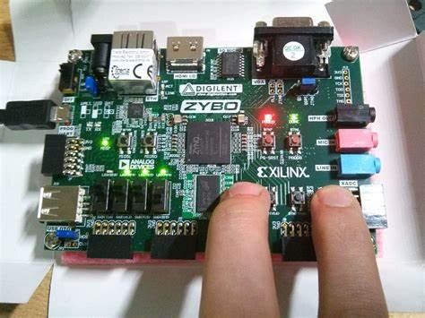

Figure 1

We can make full adder as shown in figure 2. A full adder is a digital circuit that adds three input bits, incorporating a carry-in bit along with two operands. It produces a sum output and a carry-out bit. The sum output is the XOR of the three inputs, while the carry-out is generated through a combination of AND and OR gates. The circuit comprises two half adders and an additional OR gate for handling the carry. Full adders are fundamental building blocks in arithmetic circuits, used extensively in processors, calculators, and other digital systems. They provide a mechanism for adding binary numbers efficiently, considering both the operands and the carry from the previous stage.

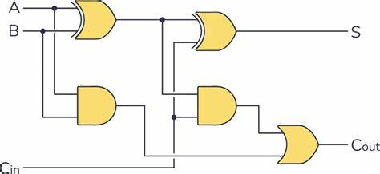

Figure 2

OBSERVATION: The observed outputs of full adder are as follows:

USING DATAFLOW:

VHDL Code: RTL Diagram:

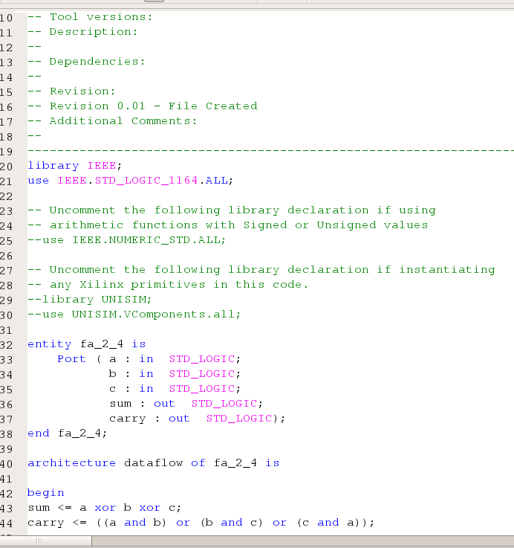 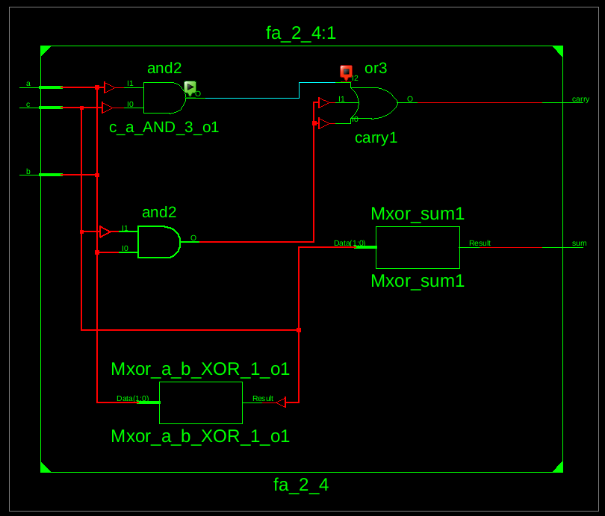

Figure 3 Figure 4

Test Bench Code:

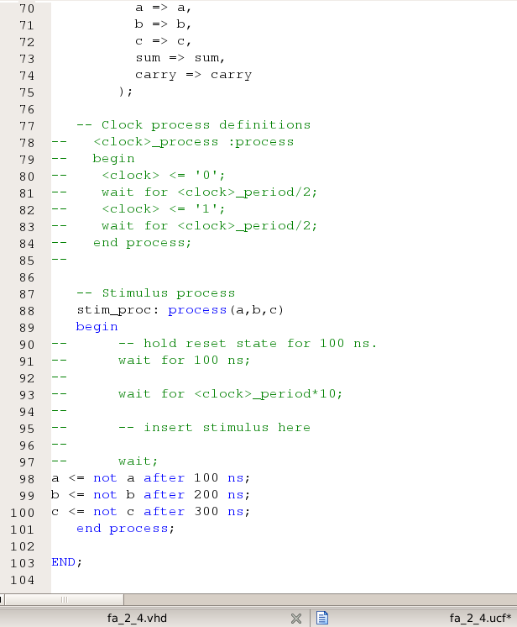 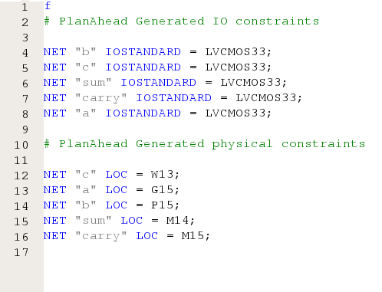

Figure 5 Figure 6

Waveform:

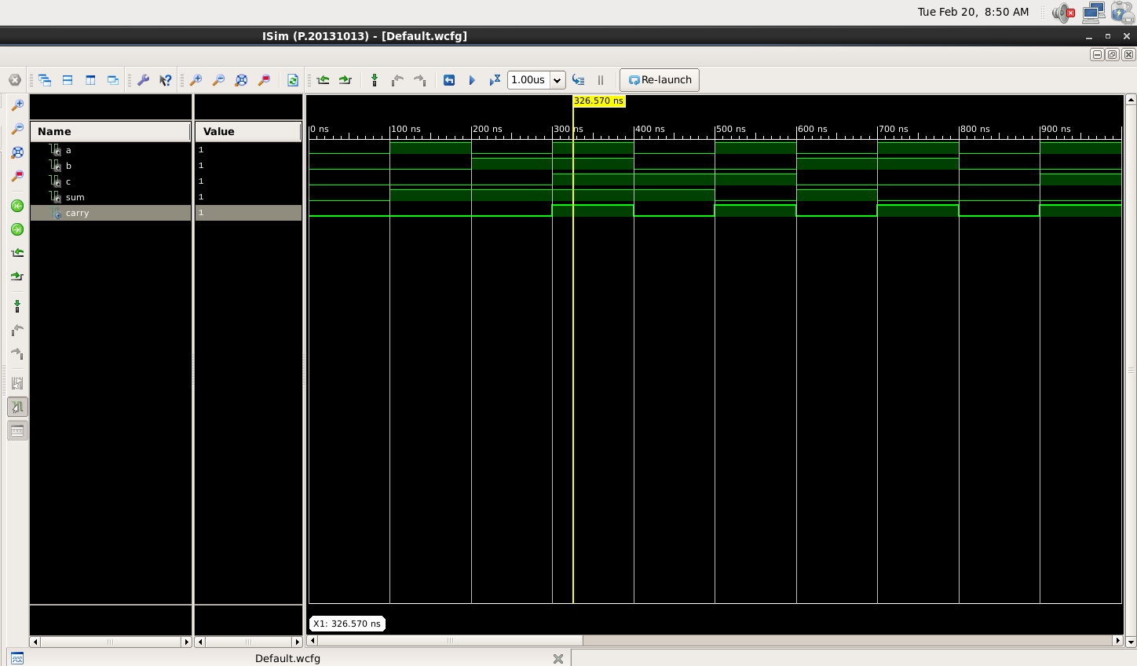

Figure 7

As we already know, that the vhdl code and rtl diagram gives the basic structure of the full adder and with the help of them we can easily conclude the truth table of full adder:

|  |  |  |  |  |
| --- | --- | --- | --- | --- |
| a | b | c | sum | carry |
| 0 | 0 | 0 | 0 | 0 |
| 0 | 0 | 1 | 1 | 0 |
| 0 | 1 | 0 | 1 | 0 |
| 0 | 1 | 1 | 0 | 1 |
| 1 | 0 | 0 | 1 | 0 |
| 1 | 0 | 1 | 0 | 1 |
| 1 | 1 | 0 | 0 | 1 |
| 1 | 1 | 1 | 1 | 1 |

Table 1

Figure 8

Figure 9

But to implement into the fpga boards, we have to make the usf file as well as bit file (which was read by the board itself ). Thus Figure 8 and 9 specifies the circuit and the pin numbers attached to the input and output.

Figure 10

After allocating the pin numbers and provide our devise the bit file. It can be easily observed in the FPGA board as shown in figure 10. The changes can be done through the switch present on the board.

The Equation can be drawn as :

Sum <= a xor b xor c;

Carry <= (a and b) or (b and c) or (c and a);

# RESULT: We have concluded the truth table of full adder and understand the working of the FPGA Board (zybo z-7010 zynq) using VHDL language in Xilinx ISE Tool.

APPLICATION IN DAILY LIFE:

* **Communications and Networking:** FPGAs are extensively used in networking equipment such as routers, switches, and network interface cards (NICs). They are utilized for tasks such as packet processing, protocol parsing, encryption, and traffic management. FPGAs enable flexibility and high performance in these critical networking functions.
* **Consumer Electronics:** FPGAs are increasingly being integrated into various consumer electronics devices, including smart TVs, set-top boxes, and gaming consoles. They can be used for video processing, image enhancement, audio processing, and user interface customization. FPGAs enable manufacturers to implement complex features and differentiate their products in the competitive consumer electronics market.
* **Automotive Systems:** FPGAs play a vital role in modern automotive systems, contributing to functionalities such as advanced driver assistance systems (ADAS), infotainment systems, vehicle networking, and engine control units (ECUs). FPGAs offer high reliability, low latency, and flexibility, making them suitable for demanding automotive applications that require real-time processing and adaptation to changing requirements.
* **Industrial Automation and Control:** FPGAs are extensively used in industrial automation and control systems for tasks such as PLC (Programmable Logic Controller) programming, motion control, process monitoring, and machine vision. FPGAs offer deterministic performance, high-speed processing, and customization capabilities, making them ideal for industrial applications that demand precision and reliability.
* **Medical Devices:** FPGAs are employed in various medical devices and equipment, including MRI machines, ultrasound systems, patient monitoring devices, and laboratory instruments. They are used for signal processing, image processing, sensor interfacing, and data acquisition. FPGAs enable high-performance computation and customization to meet the specific requirements of medical applications.